Tips for people who are blind or have low vision – becoming a confident road user

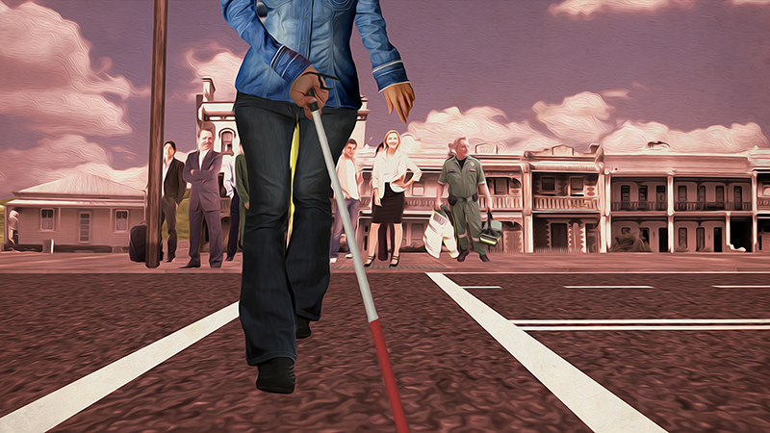
IMAGE – a person with white cane is crossing the road.

General rules for pedestrians:

- Be visible; wear clothing that other road users can see.
- Avoid stepping out between parked cars, near bends or at the crest of a hill.
- Cross in safe locations such as pedestrian lights and marked crossings.
- Allow enough time to cross the road; don’t rush.
- Once on the road do not hesitate; Act predictably so that drivers can anticipate what you are about to do.
- Have your vision checked regularly.
- The most important rule to remember when crossing a road is to stop, look, listen and think.

Types of road crossings:

- Uncontrolled crossings can be unsafe to cross because traffic does not have to stop.
- Marked pedestrian crossings (also known as zebra crossings) are simple to identify as they have white lines which contrast with the road and often have a yellow sign identifying the crossing.
- Traffic light controlled crossings are safer than pedestrian and uncontrolled crossings because they control traffic and indicate when it is safe to cross.
- Audio tactile signalised crossings are the safest type of crossing to use because they provide audio, visual and tactile signals (felt by placing your hand on the button).
- When choosing the safest place to cross a road, look for marked pedestrian crossing lines or a pedestrian crossing with audio signals.
- Where possible, keep to known routes, where you are familiar with conditions.
Get an assessment and training:
Guide Dogs Victoria and Vision Australia provide Orientation and Mobility assessment and training. Orientation and Mobility specialists can assist you in the skills, techniques and the use of mobility aids to assist you to get around safely.

For further information:
Vision Australia
Telephone: 1300 847 466 or go online to www.visionaustralia.org

Guide Dogs Victoria
Telephone: (03) 9854 4444 or go online to www.guidedogsvictoria.com.au

“I might not see you, but you can always see me”
Road safety for people who are blind or have low vision.

Vision Australia and Guide Dogs Victoria, with the support of the Victorian Community Road Safety Partnership Program, are working together to increase pedestrian and road safety.

